Transform4Europe:
The European University for Knowledge Entrepreneurs
Erasmus+ European Universities
ERASMUS-EDU-2023-EUR-UNIV-1
Project No. 101124432
06/05/2024

Transform4Europe:
the European University for
Knowledge Entrepreneurs
MILESTONE 83
First bi-annual calls on common cultural activities launched

Prepared by:
University of Trieste
Work Package 7
Dr. Alessandro Carrieri & Dr. Giuseppe Grimaldi
Contact:
alessandro.carrieri@units.it; giuseppe.grimaldi@units.it

 | 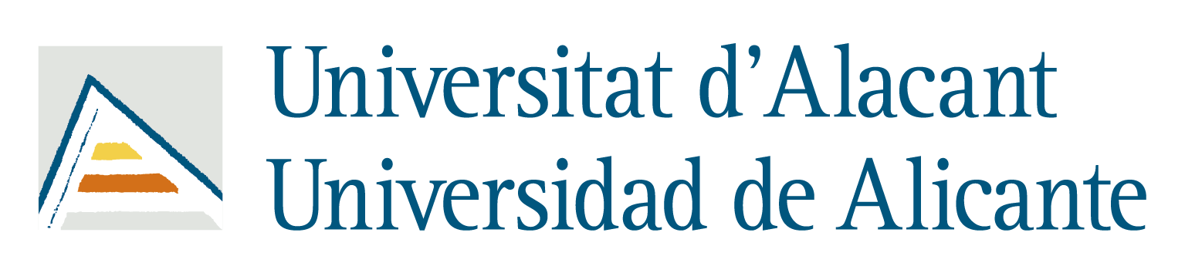 | 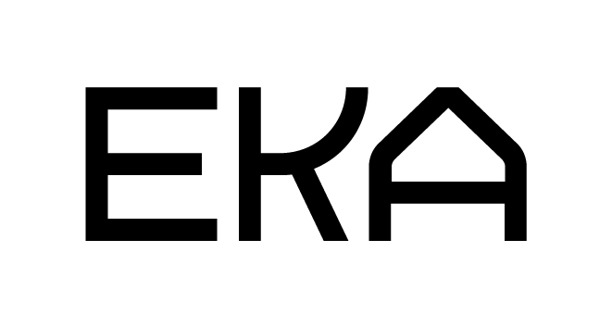 |  | 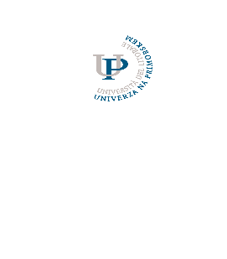 | 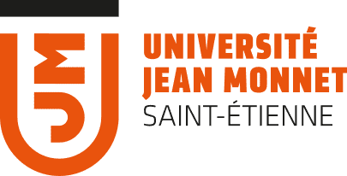 | 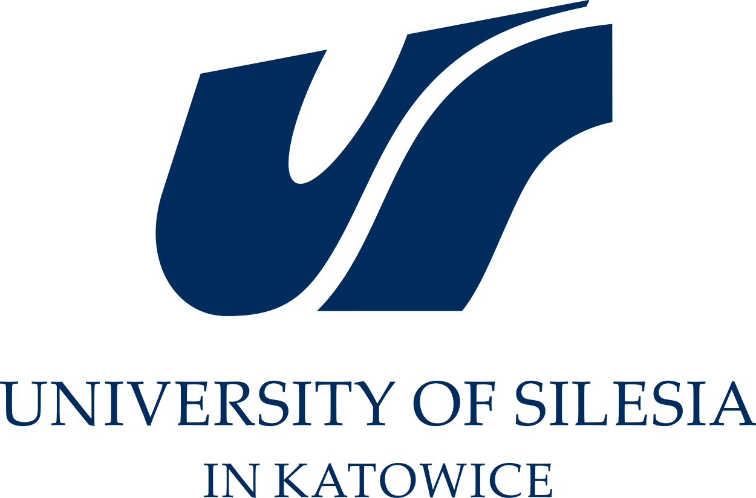 | 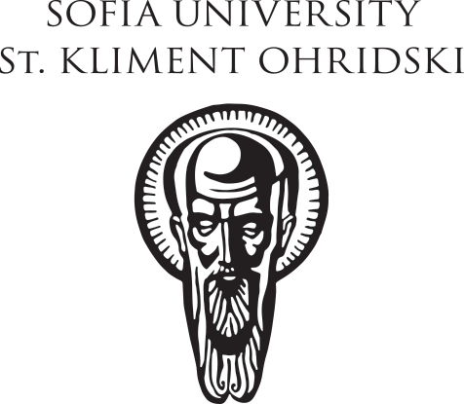 | 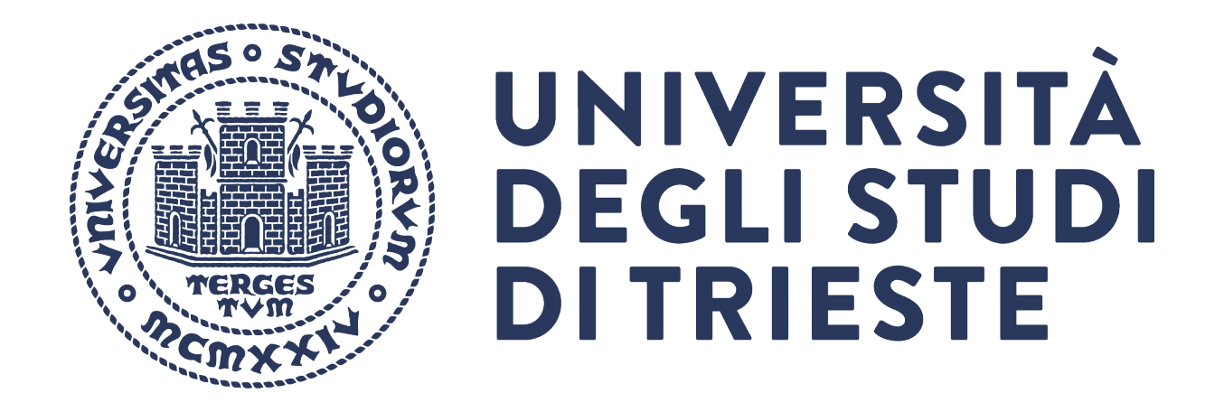 | 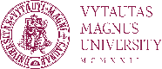

Disclaimer: The content of this document represents the views of the author only and is his/her sole responsibility. The European Commission and the Agency do not accept any responsibility for use that may be made of the information it contains.

Table of Contents

1. Approval 1
2. Introduction 1
3. Background 1
4. Purpose 2
5. Eligibility 2
6. Activities 2
7. Selection Process 3
8. Deadlines 3
9. Conclusion and contact information 3

- Approval
Approved by:
☐ USAAR
☒ UA
☐ EKA
☐ UCP
☐ UP
☐ JMU
☐ USil
☐ SU
☐ UNITS
☐ VMU

- Introduction

We are pleased to announce the “First bi-annual calls on common cultural activities” for T4EU culture and heritage, aimed at celebrating and promoting the rich tapestry of Sustainable Common European Heritage through engaging cultural and educational events.

Transform4Europe – T4EU aims at becoming one integrated European University based on shared European values, a diverse and inclusive alliance deeply rooted in the respective regional ecosystems, educating and training knowledge-entrepreneurs as drivers of transformation for the benefit of sustainable and resilient European societies.
Sustainable Common European Heritage refers to the diversity of the collective cultural, historical, and social legacy shared across Europe. A common background is essential for Sustainable Common European Heritage as it promotes unity, inclusivity, a common identity formation, peace, reconciliation, and European integration. It emphasizes both the shared historical experiences and the rich diversity of cultures that make up Europe. It serves as a foundational narrative fostering a sense of belonging and identity within Europe and beyond, providing a rationale for the formation and supporting various regional and international initiatives. This initiative is part of the T4EU culture and heritage program.

- Background

The Idea of a Common European Heritage emerged after World War II, aiming to foster a shared sense of belonging and identity among European citizens, while respecting diversity. Across the decades the necessity to make it sustainable for future generations became an imperative. Central to this concept is the recognition of a common background amid national differences, necessitating an inclusive as well as a critical definition that integrates foundational and contemporary memories – even controversial and contrastive acknowledges historical, social, and civil rights, multiculturalism and embraces diverse beliefs while upholding secularism.

- Purpose
The purpose of this call for proposals is to support four (4) multidisciplinary activities (for a budget of 10.000 euro each) that celebrate and promote Sustainable Common European Heritage multiculturalism and multilingualism.
We seek proposals that recognize the multifaceted nature of heritage, viewing it not only as a conservation effort or aesthetic pursuit but also as a dynamic tool for shaping present and future identities and fostering sustainable development within the EU. Additionally, we aim to develop Common Cultural Activities encouraging active participation in public engagement and academic knowledge sharing. Through collaboration and exchange, these activities will enhance understanding and appreciation of Common European Heritage.

- Eligibility

We welcome proposals from T4EU members and involving cultural organizations, heritage institutions, community groups, and other entities actively engaged in promoting European culture and heritage. Collaborative proposals involving partnerships among more universities of the T4EU alliance also with their regional stakeholders are particularly encouraged. We encourage the involvement of student groups in the creation/implementation/dissemination of the activities in order to enhance intergenerational connections as well as transnational exchanges among the students of the alliance.

- Activities

We encourage proposals for activities contributing to the celebration and promotion of Sustainable Common European Heritage on one or more of the following themes:
- tangible heritage,
- intangible heritage,
- environment and heritage,
- heritage and generations,
- work and heritage,
- conversion and heritage.
The activities should intersect the following working areas:

1. Workshop/Lectures in Critical Heritage Studies: Proposals for cycles of workshops or lectures exploring Critical Heritage Studies and its relevance to understanding and interpreting Sustainable Common European Heritage are encouraged. These events should provide opportunities for in-depth exploration and discussion of critical approaches to heritage interpretation.

2. GLAM Network Engagement: We encourage activities involving the GLAM network (i.e. exhibitions, audio-visual productions, performative actions and lectures, live art events) in developing educational, learning, and research pathways related to Common European Heritage. This engagement should aim to enrich both the hosting and hosted contexts within the GLAM network by encouraging the exchange of experiences among entities from different backgrounds.

Submission Guidelines
- Proposals should include a detailed description of the proposed event, including its objectives, target audience, program outline, and potential partners or collaborators. The proposals should be submitted through the Annex A – Annex_A

- Proposals should have a budget of 10.000 Euro
- Proposals should demonstrate alignment with the themes and principles of Sustainable Common European Heritage as outlined in this call for proposals.
- Proposals should be able to intersect with the WP7 main purposes (referring to milestones, workshops and culture events). See Grant_Agreement

- Selection Process
A review panel consisting of representatives from T4EU nominated among the WP7 experts group (maximum one expert per partner) will evaluate all submitted proposals based on criteria such as relevance to the theme, creativity and innovation, wideness of the partnership and potential impact on the T4EU alliance, feasibility, ability to reach WP7 milestones, and alignment with Sustainable Common European Heritage principles. The reviewers should not be involved in the proposals to avoid any possible conflict of interests.

- Deadlines
- Electronic submission of the proposals to [T4EUheritage@units.it]: 28th February 2025.
- Start of the work of the reviewers (to avoid conflict of interests): 15th March 2025
- End of the work of the reviewers and publication of the selected projects: 30th April 2025
- Public ceremony of communication of the selected projects: first T4EU Festival of Culture and Languages (June 2025 in Trieste).
* If there aren't enough proposals or if the reviewers decide that fewer than four proposals deserve funding, a new call will be issued to reach the totality of four projects funded.

- Conclusion and contact information
We encourage T4EU members and stakeholders to seize this opportunity to celebrate and promote our shared cultural heritage. By coming together to celebrate Sustainable Common European Heritage, we can foster a sense of unity, awareness, and belonging across Europe.

For inquiries or further information, please contact alessandro.carrieri@units.it; giuseppe.grimaldi@units.it

