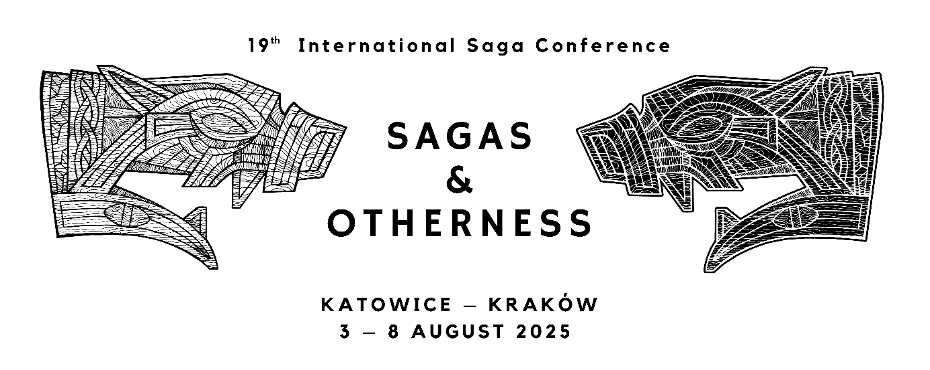

Katowice, 23 February 2024

**2nd Circular Letter**

Dear friends and colleagues,

It is our pleasure to welcome you to the Nineteenth International Saga Conference, which will take place in Katowice and Kraków on 3 – 8 August 2025.

We are happy to announce the following keynote speakers:

Sirpa Aalto (University of Oulu)

Ármann Jakobsson (University of Iceland)

Bjørn Bandlien (University of South-Eastern Norway)

Rebecca Merkelbach (University of Tübingen)

Olof Sundqvist (University of Stockholm)

In this second circular, we would like to guide you through the registration process.

Proposals should be submitted online before 1 June 2024 through our online form: <https://systemcoffee.pl/?lang=en&go2rej=1&kid=1540>

In order to do so, you will need to create a personalized account. Please keep your username and password, as you will need them in the later stages of registration and during the conference to access your account. Once registered, you will receive a summary of your data. Your account also allows you to pay the conference fee and to receive an invoice, as well as to register for conference excursions and accompanying events. It will also grant you access to all online sessions.

In this first stage of registration, you are asked to provide your personal and institutional data. For those who wish to present at the conference please also include a title and an abstract of your proposed submission (up to 2000 characters, ca. 300 words).

At this stage, you are also asked to choose a preferred strand and session format, as well as a preferred mode of participation (in person or online).

Once your profile is created and your abstract submitted, you will be able to access and edit your personal and institutional data, as well as your title and abstract. Please note that after 1 June 2024, it will not be possible to modify your title and abstract anymore.

Once you have registered, please use the following link to access your account: <https://admin.systemcoffee.pl/>

In order to log in, use the same username and password combination that you used to create an account during the initial registration.

Sessions are based on the following formats:

Individual papers

Round tables

Group sessions (comprising a set of three separate papers)

Papers may be given in all Scandinavian languages, Icelandic, English, French and German, but all round table discussions should be in English. The title and abstract should be in the language of the presentation.

Individual papers, as well as papers in group sessions, should be planned for 20 minutes of presentation followed by 10 minutes of discussion. Round table discussions will be limited to 90 minutes

Round table discussions and group sessions are led by a main organiser who should coordinate the registration. The organiser provides the topic and abstract of the session, as well as names and affiliations of participants. Participants of round table discussions and small sections are also asked to register, specifying the name of the organiser as well as the topic of the session.

The organizing committee will notify presenters of its decisions by November 2024.

For practical information about the city of Katowice, accommodation, and public transport, please visit the website: <https://welcome.katowice.eu/>

For further information about the conference, please visit the conference website at:

<https://saga2025.us.edu.pl/> or <https://us.edu.pl/wydzial/wh/en/konferencje-naukowe/sagaconference2025/>

You can also visit our Facebook page at <https://www.facebook.com/CBNiSUS>

or contact us at: [saga2025@us.edu.pl](mailto:saga2025@us.edu.pl)

Please forward this circular to anyone who might be interested in participating in the conference.

We look forward to seeing you in Katowice in 2025!

The organizing committee

Dr Grzegorz Bartusik (University of Silesia)

Assoc. Prof. Rafał Borysławski (University of Silesia)

Dr Carina Damm (University of Silesia)

Dr Remigiusz Gogosz (independent scholar)

Dr Annett Krakow (University of Silesia)

Assoc. Prof. Jakub Morawiec (University of Silesia)

Dr Ryder Patzuk-Russell (University of Silesia)

Dr Marta Rey-Radlińska (Jagiellonian University)

Dr Kendra Willson (Jagiellonian University)