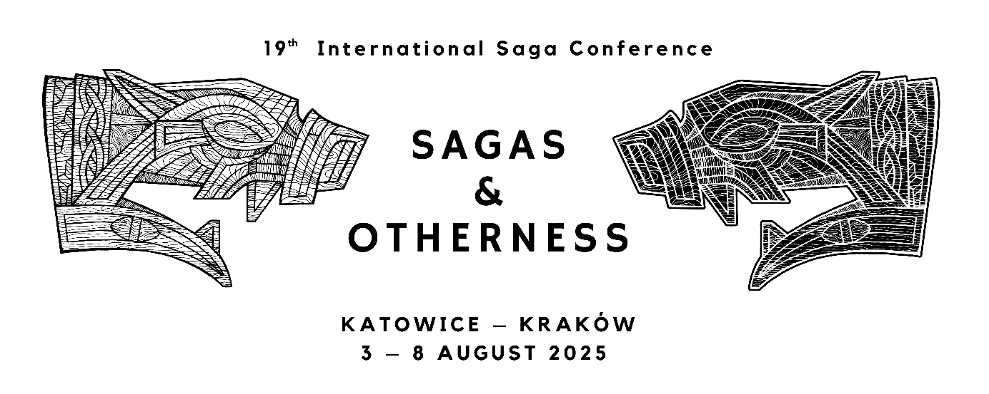

Katowice, 16 October 2023

**1st Circular Letter**

Dear Friends and Colleagues,

It is our pleasure to welcome you to the Nineteenth International Saga Conference, which will take place in Katowice and Kraków on 3 – 8 August 2025.

In this first circular we present you with the main theme and thematic strands of the conference. The conference website will be updated regularly and all information concerning the conference will be found there:

[saga2025.us.edu.pl](https://saga2025.us.edu.pl)

or

<https://us.edu.pl/wydzial/wh/en/konferencje-naukowe/sagaconference2025/>

The main theme of the Nineteenth International Saga Conference will be **Sagas and Otherness**.

This theme will be divided into the following strands:

* Christianity and Pagan Beliefs
* Meeting the Other in the Mythical World
* Medievalism and the Sagas / Reception of the “Other” in Old Norse Literature
* Methodological Diversity in Old Norse Studies

Instead of an “open session,” we will be accepting proposals for round table discussions or small sections, in accordance with recent conference practice. The participants may suggest their own topics interpreting the main theme of the conference. The programme will also include plenary lectures.

The conference will be held at the University of Silesia in Katowice and the Jagiellonian University in Kraków.

Participants will be responsible for booking their own accommodation in Katowice, where majority of the conference sessions will take place. In late summer 2024, we will post accommodation suggestions on the conference website.

The programme will include one day (Thursday) dedicated to excursions.

**Important Dates**

October 2023: 1st circular

February 2024: 2nd circular and call for papers

1 June 2024: deadline for submission of abstracts

October 2024: review of abstracts completed

November 2024: 3rd circular, conference fees and payment procedure

February 2025: 4th circular – preliminary programme published

March 2025: online registration opens

June 2025: 5th circular – final programme published

**Contact Information**

For further information about the conference please contact: [saga2025@us.edu.pl](mailto:saga2025@us.edu.pl)

or visit the website: [saga2025.us.edu.pl](https://saga2025.us.edu.pl)

This circular is being sent to those who participated in the last two Saga Conferences.

Please forward it to others who might be interested.

We look forward to seeing you in Katowice and Kraków in 2025!

Yours sincerely, the organising committee:

Dr Grzegorz Bartusik (University of Silesia)

Assoc. Prof. Rafał Borysławski (University of Silesia)

Dr Carina Damm (University of Silesia)

Dr Remigiusz Gogosz (independent scholar)

Dr Annett Krakow (University of Silesia)

Assoc. Prof. Jakub Morawiec (University of Silesia)

Dr Ryder C. Patzuk-Russell (University of Silesia)

Dr Marta Rey-Radlińska (Jagiellonian University)

Dr Kendra Willson (Jagiellonian University)